**MDP Code for Workflow Assignment**

**Key elements**

* **Number of Components and Number of Virtual machine**

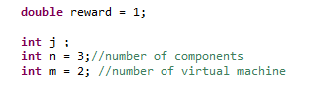

* **Cost**



* **The convergence threshold for MDP**

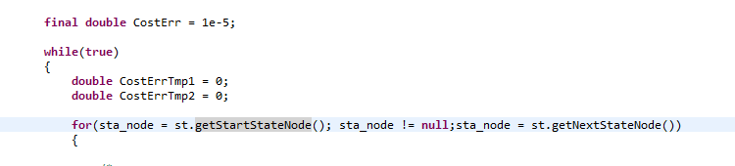

* **The condition of state transfer successfully**



* **State and Transition**



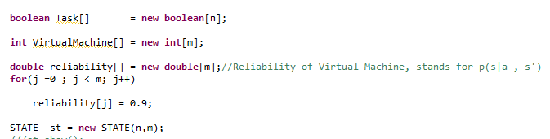

* **Iteration for MDP State**

C:\Users\Runyu\AppData\Local\Temp\enhtmlclip\Image.png

* **Iteration for MDP Action**

C:\Users\Runyu\AppData\Local\Temp\enhtmlclip\Image(1).png

* **Record optimal**

C:\Users\Runyu\AppData\Local\Temp\enhtmlclip\Image(2).png

**Output**

**For 3 task and 2 VM**

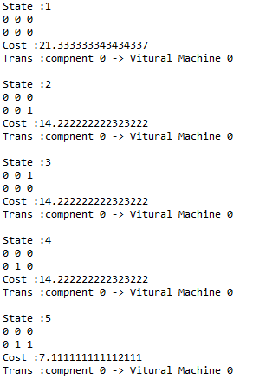

….

**Code Explanation**



Figure 1. Code file relation and structure



Figure 2. Code file classification

**Code File Structure**

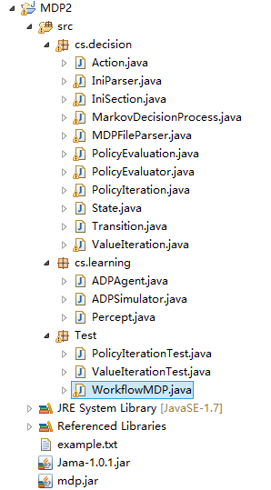

Figure 3. Code files